

AUGUST, 2024 EXAMINATION SERIES
COURSE: PPFT
LEVEL: Y1S2
SUBJECT: PLUMBING OF SPECIAL SYSTEMS

No. | QUESTION | Marks | Section in OS

SECTION A: COMPULSORY

QUESTION ONE (10 MARKS)
1 | Which of the following is the best practice before starting installation work to ensure safety?  - Read the installation manual  B. Skip safety checks  C. Rush through preparation  D. Work alone | (1 mark) | 1.4
2 | The following are safety gears to be used during drip irrigation installation, which one is not?  - Gumboots  - Helmet  - Sunglasses  - Apron | (1 mark) | 1.4
3 | Which of the following information is not contained in the title block in a technical drawing  - Scale  - Client details  - Specification details notes  - Drawing view | (1 mark) | 1.1
4 | The following are tools and equipment used in the installation of biogas system, which one is not?  - Hacksaw  - But fusion machine  - Welding machine  - Tangit | (1 mark) | 2.1
5 | The following materials are fed into the biodigester for biogas production, which one is not?  - Pig manure  - Water hyacinth  - Kitchen food remains  - House and street sweepings | (1 mark) | 2.3
6 | Which of the following irrigation method is best suited for sandy soils?  - Furrow Irrigation Method  - Basin irrigation method  - Drip Irrigation Method  - All of the above | (1 mark) | 1.3
7 | The following are components of a sprinkler irrigation system, which one is not?  - Filter  - Lateral line  - Main line  - Emitters | (1 mark) | 1.3
8 | Which tool is essential for cutting irrigation pipes to the desired length?  - Hacksaw  - Screwdriver  - Pliers  - Hammer | (1 mark) | 1.2
9 | Drip irrigation could be used to grow rice, true or false  - True  - False | (1 mark) | 1.3
10 | Biogas is used for the following purposes except?  - Cooking  - Lighting  - Heating  - Electricity generation | (1 mark) | 2.2

SECTION B (40 MARKS): ANSWER ALL QUESTIONS
11 | State any two benefits of carrying out irrigation. | (2 marks) | 1.3
12 | Name five sources of water for irrigation. | (3 marks) | 1.3
13 | The diagram shows a certain type of irrigation system, identify the system and name three types of crops grown using the systems.  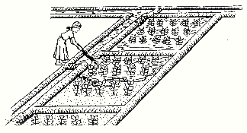 | (4 marks) | 1.3
14 | Identify the plumbing features labelled 2, 3, 4 7, 8, 18, 20 and 21 in the drip irrigation system  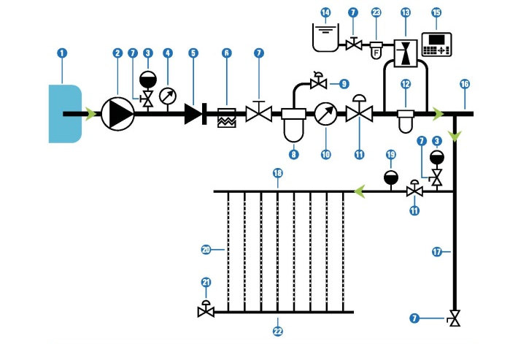 | (8 marks) | 1.4  1.1
15 | With the aid of a diagram, identify the major components of a drip irrigation system. | (10 marks) | 1.4
16 | Outline five operation and maintenance practices in biogas systems | (5 marks) | 2.5
17 | Name five tools and equipment used in sprinkler irrigation installation. | (5 marks) | 1.4
18 | Identify three causes of less gas production in biogas plant. | (3 marks) | 2.5

