 | Questions | marks | section
 | Section A
1 | Which among the following is not a pipe fitting?  - Elbow  - End cup  - Die stock  - Tee joint | (1 mark)
2 | Identify an environment where sand cannot be sourced from  - Lake  - Sea  - River  - Quarry | (1 mark)
3 | Name a material which is not a non-ferrous material.  - Steel  - Copper  - Magnesium  - Tin | (1 mark)
4 | Identify the one which is not a property of engineering materials  - Physical property  - Geothermal property  - Chemical property  - Mechanical property | (1 mark)
5 | The following are the classes of G.I pipes except  - Class A  - Class B  - Class D  - Class C | (1 mark)
6 | Identify the odd one out when sizing the elbow fitting  - 45⁰  - 20⁰  - 60⁰  - 90⁰ | (1 mark)
7 | Identify a boring tool  - Claw hammer  - Chisel  - Screwdriver  - Drill bit | (1 mark)
8 | The term first aid is defined as help given to  - The machine when it breaks down.  - A person who had an accident.  - Another person operating a machine.  - Carpenters to operate a machine. | (1 mark)
9 | Which one is not a constituent of concrete?  - Cement  - Ballast  - Adhesives  - Water | (1 mark)
10 | Identify ways in which most fires can be extinguished  - Increasing the heat so the fire burns more quickly.  - Removing the source of fuel.  - Increasing the level of oxygen.  - All of the above. | (1 mark)
 | SECTION B
11 | State THREE basic roles of a plumber in Water Distribution | (3 marks)
12 | Explain FOUR categories of plumbing tools giving one example for each | (4 marks)
13 | Describe procedures of joining PPR pipes | (5 marks)
14 | Explain FIVE reasons why HDPE pipes are preferred in water supply | (5 marks)
15 | Name the following pipe fittings and state where each is used  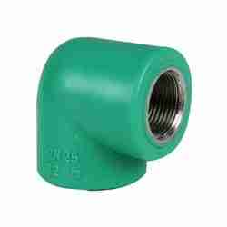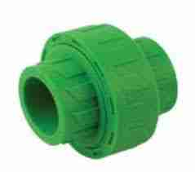  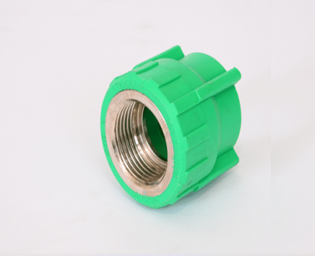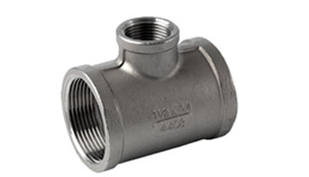  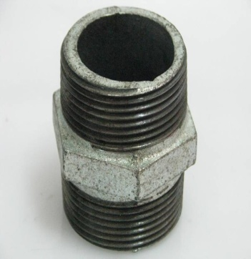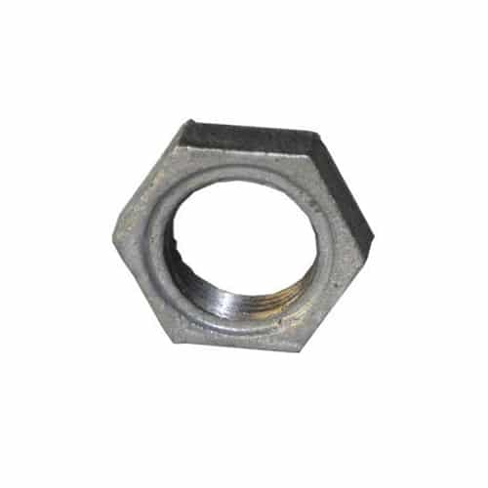 | (6 marks)
16 | Outline any TWO methods used for joining large diameter pipes | (2 marks)
17 | Explain three objectives of timber seasoning | (3 marks)
18 | Name five marking and measuring tools in carpentry workshop | (5 marks)
19 | After concrete is mixed, it needs to be transported. Explain three precautions that should be taken into considerations when transporting concrete | (3 marks)
20 | Explain three physical properties of engineering materials stating examples | (3 marks)
21 | State four advantages of using ready mixed concrete | (2 marks)
22 | Explain FOUR uses of welding tools | (2 marks)
23 | Using neat sketches illustrate the following pipe fittings  - End plug  - Reducing socket  - Three-way tee  - Union | (4 marks)
24 | State THREE importance of flux in an electrode | (3 marks)

