

AUGUST, 2024 EXAMINATION SERIES
COURSE: ICT
LEVEL: Y1S1
SUBJECT: APPLIED BASIC ELECTRONICS

SECTION A
- Draw a well labeled electronic structure of an atom (3marks)
- Define the term inductor as used in electronics (1mark)
- John moves a magnet, upwards then downs, through a conductor connected to a galvanometer as shown in figure1. Explain what happens on the galvanometer on each occasion of the movements. (2marks)

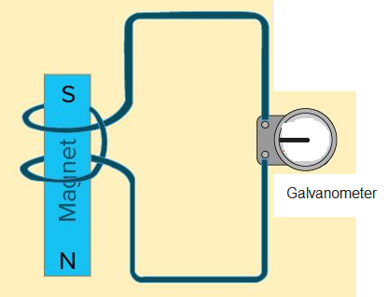
Figure 1
- Copy the diagram and name the labeled components in the electrical circuit in Figure1 (3marks)
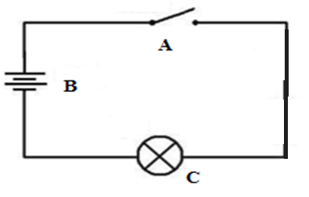
Figure 2
- Calculate the combined capacitance of the network shown in the figure2
(3marks)
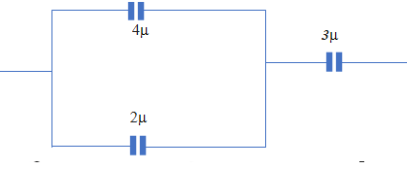
Figure 3
- Figure3 shows a battery with potential difference of 12V connected to two resistors with rating of 2ohms and 3ohms respectively. Determine the amount of current flowing through the circuit. (4marks)
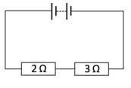
Figure 4
- Contrast the conduction of electricity in insulators and semiconductors using the energy band theory (4marks)

- Distinguish between extrinsic and extrinsic semiconductors (2marks)
- Explain why the resistor shown in the figure5 is not suitable for measuring resistance in an AC Current. (4marks)
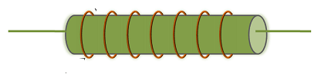
Figure 5
- Describe briefly how to make silicon a p type semiconductor (2marks)
- With the help of a diagram, describe a reverse biased PN junction. (4marks)

- An input voltage of 16V is applied to the resistor chain (see Figure 6) in the circuit .
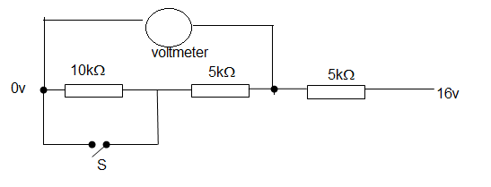
Figure 6
Determine the reading on voltmeter when (1) switch S is open (11) when the S is closed. (4marks)
- Briefly describe any four types of electronic components (4marks)
SECTION B
QUESTION ONE
- Differentiate between the term variable resistor and fixed resistor (2marks)

- Calculate the three digit codes for capacitors of value (4marks)
- 220ρF
- 82ηF

- Using color codes of the chart attached at the back page of this exam paper determine the value of the resistor resistance in figure 7. (4marks)
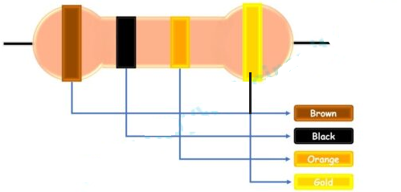
Figure 7
- The graph in figure 8 shows measurement of voltage (V) on the vertical axis, across a resistor of 10 ohms, in equal time(s) intervals on the horizontal axis.
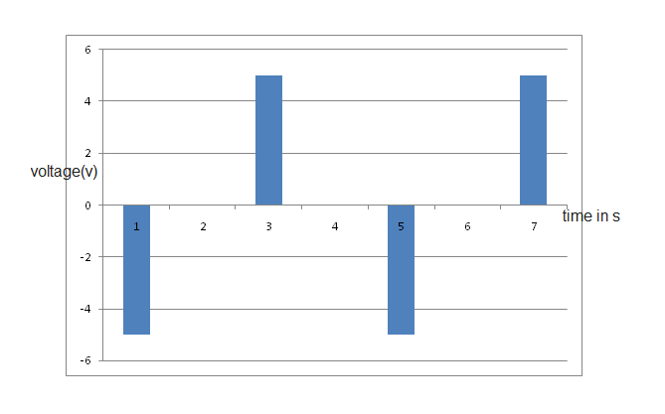
Figure 8
Use this graph to Sketch a graph for the current flowing across the resistor verses time (6marks)
- Determine the value of the currents I, I₁ and I₂ flowing in the electrical circuit shown in Figure 9. (4marks)
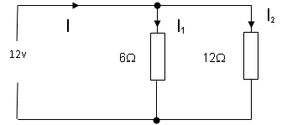
Figure 9

QUESTION TWO
- Define the term semiconductor (2mark)
- Explain the difference between a conduction band and valance band in an atom (4marks)
- Illustrate the atomic energy levels in a conductor and semi conductor affect conduction of electricity
(6marks)
- Draw a well labeled diagram to illustrate a reverse biased P-N junction (4marks)
- Describe four applications of inductors (4marks)

QUESTION THREE
- If the p.d across a resistor is 9V and it carries a current of 3m A determine Its resistance (3marks)

- Copy each of the following symbol in your answer book and state what it represented (3marks)

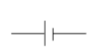
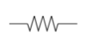
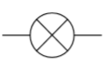

- With the help of a diagram explain the charging process of a capacitor (4marks)

- If the emf of the battery across each of the circuits is 9 volts and lamps, L1….L6, are of similar power rating.
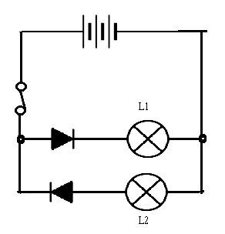 | 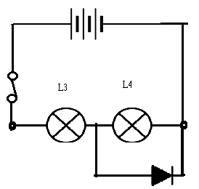
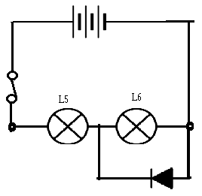

Figure 10
Show, which lamps are:
- Dim
- Off
- Bright (6marks)

- Differentiate between variable and fixed capacitor giving an example of each. (4marks)

QUESTION FOUR
- Define the term binary digit (2mark)

- Explain how the computers uses binary numbers to save data
(4marks)

- Explain four advantages of binary Numbers in computing (4marks)

- Convert 0.815 into binary digit (4marks)

- Convert (11101)₂ to BCD. (6marks)

