

 |  | AUGUST 2024 SUMMATIVE ASSESMENT
COURSE: |  | DIPLOMA IN WASTE WATER & SANITATION ENGINEERING TECHNOLOGY YEAR 2 SEM 2 (DWSET 2.2)
CORE UNITS OF LEARNING: |  | DESIGN OF WASTEWATER COLLECTION AND TREATMENT INFRASTRUCTURE II:  - SURVEY  - STRUCTURAL ANALYSIS 1  - MEASUREMENT OF WORKS & COST ESTIMETIONS ESTIMATIONS.  - ENGINEERING REPORT WRITING
TIME: 3 HOURS
INSTRUCTIONS TO CANDIDATES

- Write your KEWI number on the answer booklet and on each piece of paper used. Do not write your name anywhere in the answer booklet or any piece of paper used.
- Rough work should be done in the answer booklet and crossed through.
- This paper is divided into two sections. Attempt ALL of the questions in SECTION A and any THREE questions in SECTION B.
- Maximum marks for each question are indicated.
This paper consists of 6 printed pages.
Candidates should check the question paper to ensure that all the pages are printed as indicated and that no questions are missing.

SECTION A (40 MARKS)
Answer ALL questions in this section.
- What do the following terms mean in the context of report writing: reference, abstract, executive summary, and scope? (4 marks)
- Outline four benefits of effective listening to an organization. (2 Marks)
- Name two equipment used in accurate distance measurements in cadastral survey. (2 Marks)
- Identify four main components of a conventional level and their functions.
(4 Marks)
- A steel tape of nominal length 50.00m is used to measure a distance of 130.754m. If the tape has a standard length error of -0.002m, calculate the corrected distance. (3 Marks)
- State four applications of topographical maps in urban planning and development. (4 Marks)
- Compute the area using Trapezoidal rule (Assume offset interval of 1.5m).
(3 Marks)
Ordinate Label | 1 | 2 | 3 | 4 | 5 | 6
Offset height (m) | 3.0 | 5.5 | 7.0 | 6.5 | 4.8 | 3.2

- A copper wire, with a diameter of 10 mm and a length of 500 mm, is subjected to a tensile load of 25 KN. If the extension of the wire is 0.15 mm, determine the Young's Modulus of the copper material. (3 Marks)
- Distinguish between statically determinate structures and statically indeterminate structures. (2 Marks)
- List three assumptions made in finding out forces in frames. (3 Marks)
- Outline four steps involved in preparing a Bill of Quantities. (4 Marks)
- Constructing a wastewater treatment project requires 30 workers to work for 10 hours a day over 20 days. If the wage rate for each worker is 200 per hour, calculate the total labor cost for the project. (4 Marks)
- List two factors that may lead to variations in construction equipment costs.
(2 Marks)

SECTION B (60 MARKS)
Answer ANY THREE questions in this section.

- For the beam loaded below
- Calculate the value of the reactions. (2 marks)
- Draw the shear force diagram. (4 Marks)
- Draw the bending moment diagram. (4 Marks)

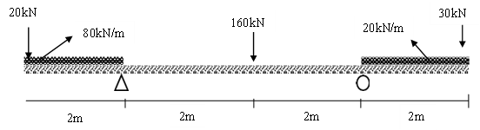

- KEWI is spearheading Implementation of two programs through ministry of water, sanitation and Irrigation, which are GTS (green toilet sanitation) and SATO (Low Cost Sanitation Toilet). You have been tasked to develop an environmental and social impact assessment technical report for the project implementation, which should be tabled before implementation committee. (10 Marks)

- The figure below shows a I-section with dimensions indicated:
- From first principles, show that Moment of Inertia of a rectangular section with width b and height h through the CoG is given by; (2 marks)
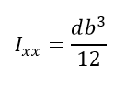
- Locate the centroid of the figure. (4 Marks)
- Calculate the moment of inertia about the horizontal neutral axis. (4 Marks)
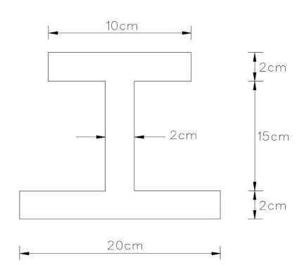

- The data below was taken during a levelling exercise for irrigation canal design.
B.S | I.S | F.S | Chainage | Remarks
1.250 |  |  | (0+00) | B.M1=100.000m A.O.D
 | 2.300 |  | (0+50) | Canal Centre A
 | 2.550 |  | (0+100) | Canal Centre B
3.000 |  | 3.150 | (0+150) | Canal Centre C
 | 1.800 |  | (0+200) | Canal Centre D
 | 2.050 |  | (0+250) | Canal Centre E
 |  | 2.100 | (0+300) | B.M2=99.500m A.O.D

- Reduce the following levelling data by either Rise and Fall method or Height of Collimation method and asses the reliability of the levelling process for engineering application. (8 Marks)
- Calculate the mean ground slope of the canal route. (2 Marks)

- XYZ Water and Sewerage Company is awarded 1 billion for expansion of their sewerage mainlines from town A to town B. As project coordinator, you have been tasked to write a technical report on a project plan for the expansion of sewerage project, which is supposed to be presented to the stakeholder meeting. (15 Marks)

- Given a foundation base of concrete with dimensions 4.500 meters long, 3.000 meters wide, and 0.750 meters deep.
- Calculate the volume of concrete required for one foundation (3 Marks)
- Given that 10 similar foundations are to be constructed, calculate the total volume of concrete required. (2 Marks)

- Find the magnitude and the type of force acting in each of the member in a framework below by a method of your choice. (10 Marks)
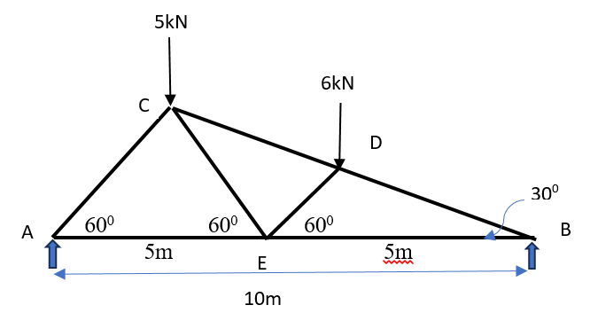

- Calculate the area using Prismoidal Rule. (4 Marks)
Cross section | A | B | C | D
Area enclosed(m²) | 1200 | 1880 | 2650 | 3480

- Using the data given in the drawing, calculate the centre line CL for an irregularly shaped building with the given internal and external girths. The wall thickness is 0.20 meters.
(6 Marks)
