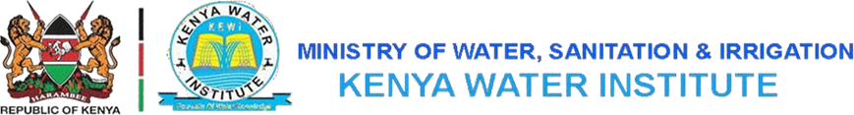

AUGUST, 2024EXAMINATION SERIES

COURSE: DWET
LEVEL: Y3 S2
SUBJECT: OPERATE AND MAINTAIN WATER SUPPLY SYSTEMS
SECTION A (40 MARKS)
ANSWER ALL QUESTIONS IN THIS SECTION

- Distinguish between the terms OPERATION and MAINTENANCE with respect to water supply systems in KENYA | (3 marks)
- Highlight any four components of a rural piped water scheme | (4 marks)
- State FOUR maintenance activities for spring developments. | (4 marks)
- Two common community water projects are wells and boreholes. State two main differences between shallow wells and boreholes. | (4 marks)
- State the operation activities of shallow wells. | (2 marks)
- Give five activities involved in ensuring proper functioning, sustainability and longevity of a community water system. | (5 marks)
- Water pans are one of the most common community water projects developed in ASALs. Clearly distinguish a dam and water pan. | (4 marks)
- Water is flowing from point A to point B. How would you arrange a meter, a gate valve and a one-way valve in order from A to B? | (2 marks)
- List any TWO reasons HDPE pipes are preferred to GI pipes | (2 marks)
- List any TWO reasons of spreading gravels on top of an underground concrete tank. | (2 marks)
- List any THREE-marker posts installed in water supply system and their corresponding meanings. | (3 marks)
- Highlight any THREE ways of minimizing water loss in a service reservoir. | (3 marks)
- Why are water meters recommended to be installed horizontally? | (2 marks)
SECTION B (60 MARKS)
COMPLETE QUESTION 15 AND ANY OTHER TWO
15.
- Identify any FIVE stakeholders and their skills required in the operation and maintenance of spring developments. | (10 marks)
- Describe the operation activities of both small-scale use and large-scale abstraction water pans. | (4 marks)
- State any THREE maintenance activities of water pans. | (3 marks)
- Identify THREE frequent problems in shallow wells and the appropriate mitigation measures for each. | (3 marks)
16.
- Using a well-labelled sketch describe the operation of sand dams. | (5 marks)
- Describe any THREE maintenance activities for sand dams. | (3 marks)
- Explain any TWO limitations water pans as a water source for the community. | (4 marks)
- Identify any FOUR stakeholders and their skills required in the operation and maintenance of water pans. | (4 marks)
- Explain any TWO limitations of shallow wells | (4 marks)
17.
You are the technical manager of Kericho Water and Sewerage Company. A group of students from Kenya Water Institute approached your company on a field academic tour with the following maintenance questions. Write down the response of your discussion.
- Explain any THREE major types of regular maintenance of assets in your water supply system. | (9 marks)
- Name any TWO departments responsible for maintaining assets in your water supply system. | (2 marks)
- Highlight procedure followed when repairing a broken asset in your water supply system. | (5 marks)
- Highlight how you prevent and/or anticipate to prevent tank overflows in your water supply system. | (4 marks)
18.
You are the area technical manager in Kisumu Water and Sewerage Company. The area of your jurisdiction is 5Km² with various water supply system infrastructure.
- Explain how you can easily identify and repair a leak along the main water pipe. | (5 marks)
- Discuss how you would trouble shoot a pump within your area. | (6 marks)
- Explain procedure you would follow from identification to installation of service water meter. | (6 marks)
- Highlight ANY THREE areas you would prefer GI pipes unlike UPVC pipes. | (3 marks)

