
AUGUST, 2024 EXAMINATION SERIES

COURSE: DWET
LEVEL: Y2S2
SUBJECT: DESIGN OF WATER SUPPLY & TREATMENT INFRASTRUCTURE I

SECTION A (40 MARKS)
ANSWER ALL QUESTIONS IN THIS SECTION
- Highlight TTHREE factors influencing population Projection. |  | 3marks
- A 30-m-diameter sedimentation basin has a side water depth of 3.0 m. It is treating a raw water flow of 0.3 m³/s. Compute the overflow rate and detention time. |  |  | 3 marks
- State FOUR factors considered during the design of water supply infrastructure. |  | 2 marks
- Estimate the average, maximum day, and peak hour water demand for a community of 60,000 population. Assume average water consumption of 200 Lpcd.  - Calculate the dimensions of a flocculation basin to treat a flow of 18,900 m³/d. The flocculator has a three-stage basin, with a 10-minute detention time in each stage. The basin has a width of 12 m, and total length is three times the basin depth.  - Analyse the figure below, which shows the contour map of the proposed dam and reservoir site. Redraw the contour plan, clearly indicating the location for siting the proposed dam. Also, show the upstream/downstream sides of the dam. | 4 marks  4 marks  3 Marks
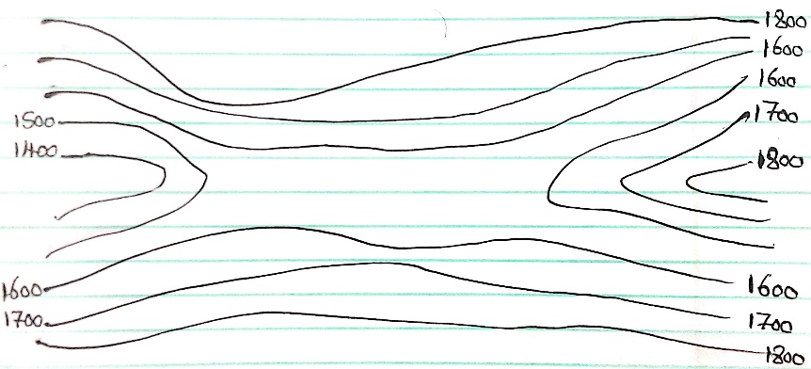
- Identify FOUR components of an earth dam. |  | 4 Marks
- State and briefly explain any THREE contents that must be included in a Standard Title Block for a Water Supply Engineering Drawing. |  | 3 Marks
- Sketch a profile of a typical alignment of a water supply main pipeline indicating where Air Valves and Washout Valves would be positioned. |  | 4 Marks
- Define the following terms, highlighting clear differences in their functionalities as designed.  - Weirs.  - Dams. |  | 2 Marks
- While drawing using AutoCAD, a scale of 0.02 was gotten in a viewport. What is the scale factor of the drawing in the format of 1:X. |  | 3 Marks
- During the investigations stage for reservoir, a contour plan is prepared. From the contour plan, Area-Elevation and Storage-Elevation Curves are prepared. Sketch the Elevation-Area-Storage Curves for a reservoir, clearly showing:  - Maximum operating level  - Minimum operation level  - Spillway crest |  | 5 Marks
SECTION B (60 MARKS)
ANSWER QUESTION 10 and ANY OTHER TWO
- a) With the help of sketches, differentiate between the following types of Dams classified by Hydraulic Design.  - Overflow Dam  - Non-overflow Dam  - Referring to the picture below, sketch a neat Plan and Vertical Section of a Rectangular cross-section River Intake (wet type) clearly showing:  - The Intake Well  - Pump House  - Entry Port(s) (Penstocks)  - Pump and accessories  - River Channel and  - River Bank  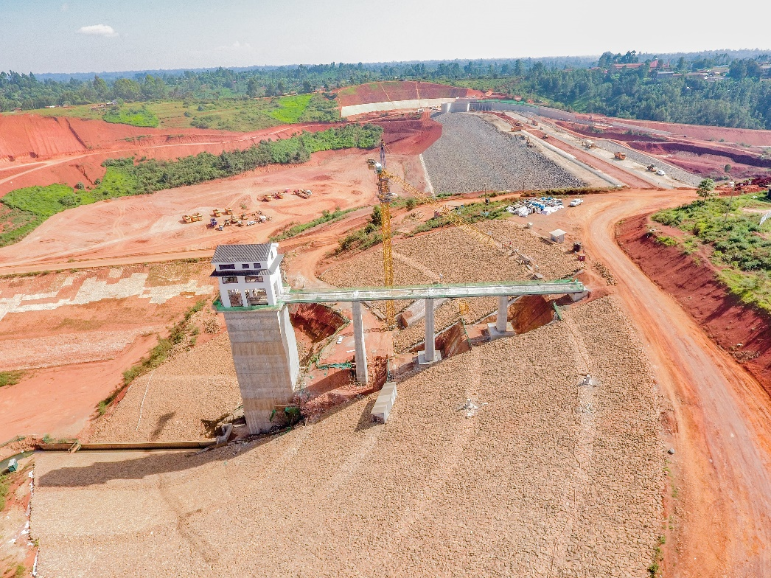 |  | 6 Marks  14 Marks
14. A small town with a design population of 2000 is to be supplied water at 150 litres per capita per day. The demand of water during different periods is given in the following table:  Assume that the production capacity of the well system is one-and-a-half-times the average day demand. Auxiliary generator power is available. There is no ES, SS, or FDS. Pumping is done for ten hours from 0400 hrs to 0800 hrs and again 1600 hrs to 2200 hrs.  Estimate:  - The required volume of a water reservoir that will supply fire protection only.  - The total volume of a water reservoir that will serve the community. |  | 5 Marks  15 marks
  Time (hrs.) | 0-3 | 3-6 | 6-9 | 9-12 | 12-15 | 15-18 | 18-21 | 21-24
  Demand(1000liters) | 20 | 25 | 30 | 50 | 35 | 30 | 25 | 25
15. A community has a population of 80,000 in the year 2000, and is expected to reach 120,000 in the year 2010. The average water demand in 2000 was 160 lpcd. It is expected that the water consumption rate will be reduced to 135 lpcd by the year 2010, Assuming that the population increase and decrease in consumption rate have a linear relationship,  a) Calculate the year when the treatment plant will reach an average treatment capacity of 20 mld.  b) Calculate the filter dimensions for a treatment plant managing a maximum flow rate of 80,000 m³/day, using filter units of length-to-width ratio of 1:3. Assume the hydraulic loading rate is 0.17 m³/m².min.  c) Highlight at least SIX design parameters to consider during the design of the water treatment plant for a town population  16. Design a water storage tank for a residential building with 10 apartments, and each apartment has an average daily water demand of 500 liters. The building owner wants to ensure a continuous water supply for at least three days without relying on external sources. Consider all safety factors and space constraints. Assume average daily water demand remains constant. Sketch the designed tank to show the shape and it dimensions |  | 8 marks  6 marks  6 marks  20 Marks

