

AUGUST, 2024 EXAMINATION SERIES

COURSE: DWET
LEVEL: Y2S2

SUBJECT: WATER SUPPLY INFRASTRUCTURE DESIGN II
Structural Analysis, Measurement, Survey

SECTION A (40 MARKS)
Answer ALL questions in this section.

- Name two equipment used in vertical angle observation in chain survey technique.
(2 Marks)
- Identify three tools used in marking survey stations for long time use under chain surveying techniques. (3 Marks)
- Given the distance as determined by a 30.00m, tape is 85.504m, calculate the corrected distance if the tape had suffered elongation of 20 mm. (4 Marks)
- State four critical information that must appear on a survey map. (4 Marks)
- A trapezoidal water trough measures 12m by 8m with a height of 4m between the parallel sides. Calculate the cross- sectional area. (4 Marks)
- A bronze rod, with a diameter of 20 mm and a length of 300 mm, is subjected to a tensile load of 40 KN. Determine the Young's Modulus of the bronze material given that the extension of the rod is 0.25 mm. (3 Marks)
- State four assumptions made in the simple theory of bending. (4 Marks)
- List three assumptions made in finding out forces in frames. (3 Marks)
- Give any three methods used in analyzing forces in frame. (3 Marks)
- Outline four steps involved in preparing a Bill of Quantities. (4 Marks)
- A construction project requires 20 laborers to work for 8 hours a day for 15 days. If the wage rate for a laborer is 150 per hour, calculate the total labor cost for the project. (4 Marks)
- Identify two factors that could lead to variations in equipment cost estimates during the execution of a construction project. (2 Marks)

SECTION B (60 MARKS)
ANSWER QUESTION 13 AND ANY OTHER TWO QUESTIONS IN THIS SECTION

QUESTION 13
- For the beam loaded below
- Calculate the value of the reactions. (2 Marks)
- Draw the shear force diagram. (4 Marks)
- Draw the bending moment diagram. (4 Marks)
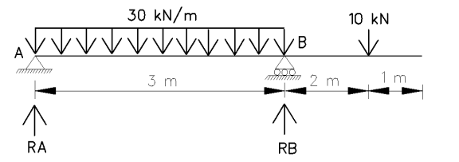
- Compute the area using the methods stated below:
- Use of Trapezoidal rule. (Assume offset interval of 2m.) (4 Marks)

Ordinate Label | 1 | 2 | 3 | 4 | 5 | 6
Offset height (m) | 2.0 | 4.5 | 7.0 | 6.5 | 4.8 | 3.2

- Using Prismoidal Excess. (6 Marks)
Cross section | A | B | C | D
Area enclosed(m²) | 1210 | 1840 | 2630 | 3460

QUESTION 14
- The figure below shows an I-section with dimensions in mm:
- From first principles, show that Moment of Inertia of a rectangular section with width b and height h through the C.o.G is given by; (4 Marks)
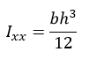
- Locate the centroid of the figure. (3 Marks)
- Calculate the moment of inertia about the horizontal neutral axis. (3 Marks)
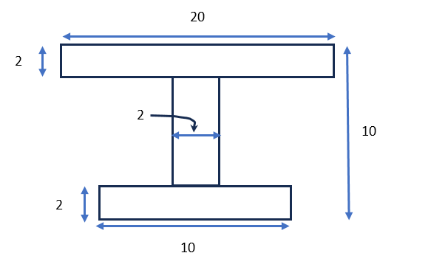
- The data below was taken during a levelling exercise for irrigation canal design.
B.S | I.S | F.S | Chainage | Remarks
1.185 |  |  | (0+00) | B.M1=1510.560m A.O.D
 | 2.435 |  | (0+30) | Canal Centre P1
 | 2.505 |  | (0+60) | Canal Centre P2
2.950 |  | 3.035 | (0+90) | Canal Centre P3
 | 1.655 |  | (0+120) | Canal Centre P4
 | 1.995 |  | (0+150) | Canal Centre P5
 |  | 1.645 | (0+180) | B.M2=1510.015m A.O.D

- Reduce the following levelling data by either Rise and Fall method or Height of Collimation method and asses the reliability of the levelling process for engineering application. (8 Marks)
- Calculate the mean ground slope of the canal route. (2 Marks)
QUESTION 15
- Using the tachy data below, calculate:
- The horizontal distance between P and Q. (5 Marks)
- The elevation of point R. (5 Marks)
- The Mean ground slope between P and Q. (5 Marks)

Inst.stn. P  R.L_{P} =1456.630 m  Inst. Height =1.550m | Target station | V.A | Stadia reading (m)  (U) (L)
Inst.stn. P  R.L_{P} =1456.630 m  Inst. Height =1.550m | Q | +7⁰ 45' 30'' | 1.690 0.530
Inst.stn. P  R.L_{P} =1456.630 m  Inst. Height =1.550m | R | -2⁰ 25' 00'' | - 1.250

- Given a foundation base of concrete with dimensions 4.500 meters long, 3.000 meters wide, and 0.750 meters deep.
- Calculate the volume of concrete required for one foundation (3 Marks)
- Given that 10 similar foundations are to be constructed, calculate the total volume of concrete required. (2 Marks)
QUESTION 16
- Find the magnitude and the type of force acting in each of the member in a framework below by a method of your choice. (10 Marks)

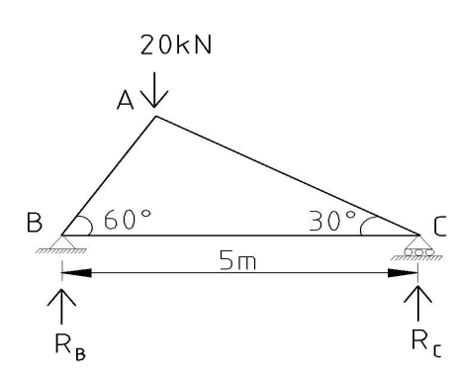

- Explain the importance of using a standard method of measurement for preparing BOQs (4 Marks)
- Using the data given in the drawing, calculate the centre line CL for an irregularly shaped building with the given internal and external girths. The wall thickness is 0.25 meters. (6 Marks)
