

AUGUST, 2024 EXAMINATION SERIES

COURSE: DWET
LEVEL: Y2S1
SUBJECT: Technical Drawing and Computer Aided Drawing

SECTION A
Attempt All Questions in this Section
- Define Computer-Aided Design (CAD) (2 marks)
- Explain the term working drawing (4 marks)
- In dimensioning, what is the standard length and width of the arrowhead
(3 marks)
- List three components of the AutoCAD window and their functions. (3 marks)
- State any 4 professionals who use AutoCAD (2 marks)
- With a sketch, show how you would dimension a circle (5 marks)
- Describe aligned system as used in dimensioning (4 marks)
- List three the methods of entering commands in AutoCAD. (3 marks)
- 4. Explain the process of offsetting objects in AutoCAD (4 marks)
- List two ways of making solids in AutoCAD (2 marks)
- Describe the two main methods of selecting an object in AutoCAD (4 marks)
- Describe unidirectional system as used in dimensioning (4 marks)
SECTION B
Attempt Question 13 and any other TWO
- a. Highlight step-by-step the procedure for starting AutoCAD (10 Marks)
- Sketch the AutoCAD screen and on it show any five general features found in the interface (10 Marks)

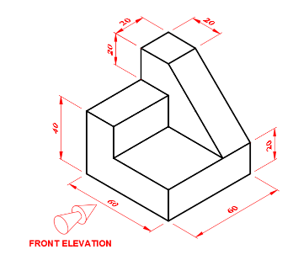
- a. In reference to the figure below, draw three views in the first angle orthographic projection. The front view is indicated using the arrow as shown. All dimensions are in mm (10 marks)
- The distance between the centers of two circles of 65 mm and 90 mm diameters is 120 mm. Construct an external tangent common to the two circles. (10 Marks)
- a. Draw a line AB, of length 100mm then divide it into 7 equal parts. (8 Marks)
b. Sketch the symbols for the pipefittings shown. (8 marks)
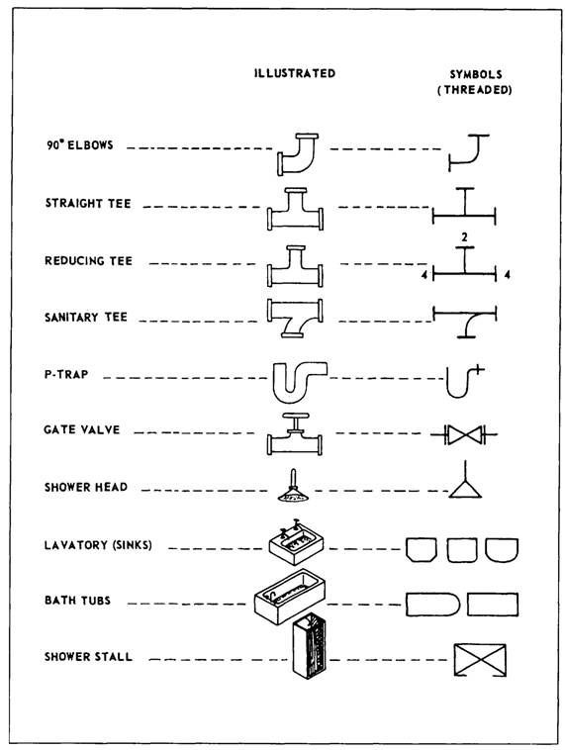
c. Draw and name four types of lines used in drawing (4 marks)

- a. Construct a regular hexagon within a circle whose radius is 35 mm. Show full geometrical construction (10 marks)
- Figure 3 below presents a third angle orthographic projection of an object. Produce a pictorial projection of the object. The given dimensions are in mm
(10 marks)

