

AUGUST ,2024 EXAMINATION SERIES
COURSE: DIPLOMA IN WATER ENGINEERING TECHNOLOGY
LEVEL:Y2S1
SUBJECT :ENGINEERING MATHEMATICS II

SECTION A (40 marks)
Answer all questions in this section
 | Given that $y=-2x^{4}-3x^{3}+4x^{2}-x+5$, find:  $$\frac{dy}{dx}$$  $$\frac{d^{2}y}{dx^{2}}$$ | (2 marks)
 | Simplify:  $$\left(3+5j\right)-\left(5-4j\right)-\left(-2-3j\right)$$ | (2 marks)
 | Find the integrals:  $$\int{\left(-6x^{3}+9x^{2}+4x-3\right) dx}$$  $$\int{\left(r^{2}-2r+\frac{1}{r}\right) dr}$$  $$\int{\left(\frac{3x^{2}+4x+1}{2x}\right)} dx$$ | (2 marks)  (2 marks)  (3 marks)
 | Evaluate:  $$2j^{2}+3j^{3}+4j^{4}+5j^{5}$$ | (2 marks)
 | Differentiate the function from first principles:  $$y=\frac{1}{x}$$ | (4 marks)
 | Use integration to find the area under the curve $y=3x^{2}+4x-5$ between $x=1$ and $x=3$. | (3 marks)
 | Express in polar form, $z=-4+2j$. | (3 marks)
 | Find the derivative of the function:  $$f\left(x\right)=\frac{2x+1}{3x-4}$$ | (4 marks)
 | Evaluate the integral:  $$\int_{-2}^{4}{\left(x^{2}-3x+1\right)} dx$$ | (4 marks)
 | Given that $y={2x}^{3}\sin{5x}$, find $\frac{dy}{dx}$. | (2 marks)
 | Given that $w=1-3j$ and $z=9-7j$, express in the form $a+bj:$  $$\frac{z}{w}$$ | (3 marks)
 | Identify the complex numbers $z_{1}, z_{2}, z_{3}$and $z_{4}$shown in Figure 1. Give your answers in Cartesian form.  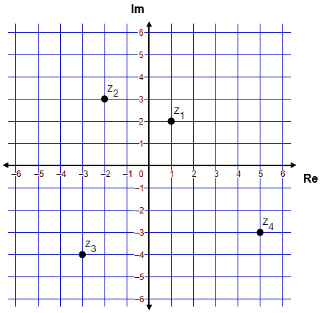  Figure 1 | (4 marks)

SECTION B (60 marks)
Answer any three questions in this section
 |  | Express $-1+j$ in the form $re^{θj}$ where $r$ is positive and $-π<θ<π$. | (3 marks)
 |  | Convert $z=e^{1+\frac{π}{2}j}$ in the form $a+bj$. | (3 marks)
 |  | If $\left(a+b\right)+j\left(a-b\right)={\left(1+j\right)}^{2}+j\left(2+j\right)$, obtain the values of $a$ and $b$. | (4 marks)
 |  | Use De Moivre’s theorem to find the two square roots of $3-4j$ in Cartesian form. | (5 marks)
 |  | Given the complex numbers $z_{1}=3+4j$, $z_{2}=5-6j$ and $z_{3}=4+7j$, evaluate the expression:  $$z_{2}-\frac{\left(z_{1}+z_{3}\right)}{z_{1}z_{3}}$$ | (5 marks)
 |  | If $y=3x^{3}+2x-4$, show that:  $$\frac{d^{3}y}{dx^{3}}+\frac{2}{9} \frac{d^{2}y}{dx^{2}}+x\frac{dy}{dx}-3y=30$$ | (5 marks)
 |  | Given that $α$ and $β$ are the roots of $x^{2}-10x+29=0$, find $α$ and $β$ using the quadratic formula. Verify that $α+β=10$ and $αβ=29$. | (5 marks)
 |  | Use De Moivre’s theorem to evaluate:  $${\left(-1-3j\right)}^{5}$$ | (5 marks)
 |  | Find the three values of the expression in polar form:  $${\left(4-3j\right)}^{-\frac{2}{3}}$$ | (5 marks)
 |  | Find the derivatives of the functions:  - $g\left(x\right)={\left(2-x^{5}\right)}^{9}$  - $f\left(x\right)=\left(1-x^{3}\right)e^{2x}$ | (2 marks)  (3 marks)
 |  | The distance $x$ metres travelled by a body in a time $t$ seconds is given by:  $$x={2t}^{3}+3t^{2}-6t+2$$  Express the velocity in terms of $t$ and find its value when $t=4 s$. | (3 marks)
 |  | Given that $y=2x^{2}-5x+3$, find $\frac{dy}{dx}$ from first principles. | (5 marks)
 |  | Find the stationary points on the graph of the function and distinguish between them.  $$y=\frac{x^{3}}{3}-\frac{x^{2}}{2}-2x+5$$ | (7 marks)
 |  | Evaluate the integrals:  $$\int_{1}^{3}{\left(\frac{1}{x^{2}}+\frac{1}{x}+\frac{1}{2}\right) dx}$$  $$\int_{1}^{3}{{\left(4x-3\right)}^{2} dx}$$ | (3 marks)  (3 marks)
 |  | Evaluate the integral using Simpson’s rule with 4 intervals. Give your answer correct to 3 decimal places.  $$\int_{1}^{3}{\frac{5}{x} dx}$$ | (4 marks)
 |  | Table 1 shows the distribution of salaries of employees in a Water Engineering firm.  Table 1  Determine the:  - mean salary;  - median salary;  - standard deviation. | (3 marks)  (3 marks)  (4 marks)
  Salary (Ksh. 000’s) | Number of employees
  10-20 | 4
  20-30 | 24
  30-40 | 16
  40-50 | 12
  50-60 | 16
  60-70 | 6
  70-80 | 10
  80-90 | 8
  90-100 | 4

