

AUGUST 2024 EXAMAMINATION SERIES
COURSE: DIPLOMA IN WATER ENGINEERING TECHNOLOGY
LEVEL: YEAR 1 SEMESTER 2
SUBJECT: WATER MANAGEMENT PRINCIPLES

SECTION A: ANSWER ALL QUESTIONS (40 MARKS)
- State TWO characteristics a material must possess for it to be identified as a mineral. (2 Marks)
- Explain TWO types of porosity in geological formations. (4 Marks)
- Highlight TWO benefits of conducting a hydro geological survey. (2 Marks)
- Explain TWO factors that influence the mass movement of the earth. (2 Marks)
- Describe any TWO forms of precipitation. (2 Marks)
- List TWO factors considered in selecting a rain-gauge installation site. (2 Marks)
- Explain TWO applications of stream flow data. (4 Marks)
- Describe ONE process of water erosion. (2 Marks)
- Name TWO free GIS data sources. (2 Marks)
- Explain TWO components of a geographic information system. (2 Marks)
- Differentiate between spatial and non-spatial data. (2 Marks)
- State TWO advantages of active remote sensing. (2 Marks)
- Differentiate between Rayleigh scattering and Non-selective scattering. (2 marks)
- State FOUR reasons why legislation is important for water management in Kenya. (4 marks)
- Explain the following terms as applied in Integrated Water Resources Management (IWRM);
- Social Equity. (2 Marks)
- Economic Efficiency. (2 Marks)
- Environmental Sustainability. (2 Marks)

SECTION B: ANSWER ANY THREE QUESTIONS IN THIS SECTION (60 MARKS)
- a)Study the satellite images and use them to answer the questions that follow:
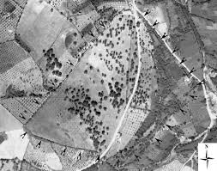  Image A | 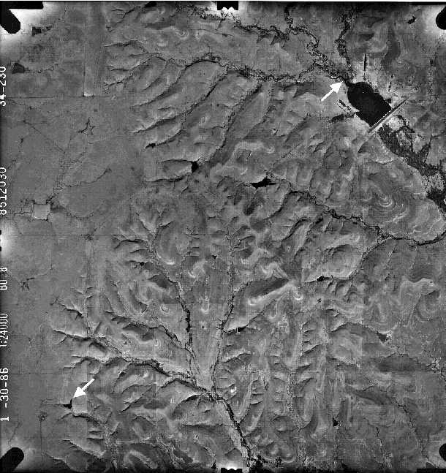  Image B
- Identify any four geographic phenomena from the satellite images above (4marks)
- b) From phenomena identified in (a) above, categorize the geographic phenomena as field, object or boundary (8marks)
- Explain three visual characteristic you would use to identify geographical objects or features from the photographs. (4marks)
b) Explain two applications of GIS in water management (4 marks)
17. (a) i)Describe THREE types of sedimentary rocks giving examples of each. (6 marks)
(ii) Explain any two applications of geo-chemistry in hydrogeology. (4 marks)
(iii) Describe any two sources of groundwater recharge. (2marks)
b) Propose a groundwater exploration plan a City located in a semi-arid area, incorporating suitable groundwater exploration techniques. (8marks)
18. (a). The table below shows point rainfall due to a storm at several rain gauge stations in a water catchment. Use the data Determine the areal rainfall by using the Thiessen polygon method (6 Marks)
Station | Rainfall recorded (mm) | Area of influential polygon km²
A | 90 | 60
B | 80 | 90
C | 110 | 65
D | 100 | 50
E | 140 | 55
(b) i)With the aid of a well-labeled diagram, explain the soil profile (4 marks)
ii) Explain any TWO principles of soil and water conservation (4 marks)
(c)Describe any three doctrines used in water resources movement in Kenya. (6 marks)
19.a) Explain five economic instruments used to regulate water resource use. (10 marks)
b) Describe five techniques awareness creation used in IWRM. (10 marks)

