

AUGUST, 2024 EXAMINATION SERIES

COURSE: DWET
LEVEL: Y1S2
SUBJECT: WORKSHOP TECHNOLOGY1

SECTION A
Attempt All questions in this Section

1 | Define the following terms;  - Electric Circuit  - Electric current | 1 Mark  1 Marks
2 | If 25 C of charge is determined to pass through a wire of any cross section area in 50 s ,what is the measure of current I | 2 Marks
3 | Differentiate between biodegradable and non-biodegradable waste | 4 Marks
4 | state the two laws of charge | 2 Marks
4 | Outline 4 most popular types of Waste Disposal | 4 Marks
5 | list FOUR main requirements for electrical and electronic installation | 2 Marks
6 | A coil consists of 2000 turns of copper wire having a cross-sectional area of 0.8 mm². The mean length per turn is 80cm and the resistivity of copper is 0.02 μΩ^{–m}. Find the resistance of the coil and power absorbed by the coil when connected across 110 V d.c. supply. | 4 Marks
7 | Explain what is meant by the following terms  - Lockout  - Danger zone | 4 Marks
8 | What are the considerations when selecting a pump | 4 Marks
9 | Suppose water is flowing from a circular pipe that has a radius of 0.0800 m. Furthermore, its velocity is 3.30 m/s. So, calculate the flow rate of water | 4 Marks
10 | What are lifting equipment | 2 Marks
11 | Define the following terms:  - First aid  - Hazard | 2 Marks
12 | Differentiate between mechanical hazards and chemical hazards giving examples for each | 2 Marks
13 | Measuring instruments are classified into two main types based on their construction, working and method of showing output. State the two. | 2 Marks
SECTION B
ATTEMPT QUESTION 14 AND ANY OTHER TWO QUESTIONS
14 | - What are the three most common causes of plant breakdown  - Identify FOUR factors to consider when purchasing a pump  - Explain THREE functions of cutting fluids.  - Outline the FOUR main procedures for conduit installation. | 6 Marks  4 Marks  6 Marks  4 Marks
15 | a) In a series of successive measurements in an experiment, the readings of the period of oscillation of a simple pendulum were found to be 2.63s, 2.56s, 2.42s, 2.71s and 2.80s. Calculate  (i) the mean value of the period of oscillation  (ii) the absolute error in each measurement  (iii) the mean absolute error  (iv) the relative error  (v) The percentage error. Express the result in proper form.  - Discuss the primary goals of first aid  - Environmental laws and regulations for workshops can vary significantly depending on the location, type of workshop, and the specific activities conducted within it. Discuss areas covered by environmental laws in workshops. | 2 Marks  2 Marks  2 Marks  1 Marks  1 Marks  6 Marks  6 Marks
16 | a) A series RLC circuit containing a resistance of 12Ω, an inductance of 0.15H and a capacitor of 100uF are connected in series across a 100V, 50Hz supply. Calculate;  i) The total circuit impedance if f=50HZ  ii) The circuits current if Vs=100V  iii) Power factor  - A computer printer operates at 30 V. The diagram shows the transformer used to step down the mains voltage from 240 V to the 30 V needed by the printer. There are 3200 turns on the primary coil.  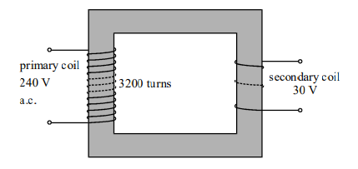  - Calculate the number of turns on the secondary coil.  - The current in the printer is 0.4 A. Calculate the energy supplied to the printer in one second  - Discuss the actions taken for proper care and maintenance of welding hand tools and machinery | 2 Marks  2 Marks  2 Marks  4 Marks  4 Marks  6 Marks  2 Marks  2 Marks  2 Marks  7 Marks  7 Marks
  17. | - The table lamp shown in Fig. 10.2 is made from plastic. It has only two wires in the cable to connect it to the plug.  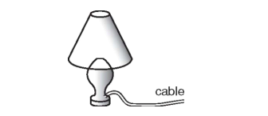  The lamp has a power rating of 100 W and is used with a 230 V supply.  - Which wire, earth, live or neutral, is not needed in the cable for the lamp?  - Explain why the lamp is safe to use even though it has only two wires in the cable.  - Explain what is meant by a power rating of 100  - Discuss the disadvantages of sanitary landfill method as an option for the disposal of solid waste  - Discuss the categories of waste that National Environmental Management Authority regulates | 1 Mark  2 Marks  3 Marks  7 Marks  7 Marks

