

AUGUST, 2024 EXAMINATION SERIES
COURSE: DIPLOMA IN WATER ENGINEERING TECHNOLOGY
LEVEL: Y1S1
SUBJECT: ENGINEERING MATHEMATICS 1

SECTION A (40 marks)
- Solve for x in the in the following equation.
- 3^{2x + 1} – 11(3^{x}) + 6 = 0. (4 marks)
- $\log_{3}{x}=\log_{9}{4}$ (3 marks)
- Show that:
- sin3θ = 3sinθ − 4sin³θ (3 marks)
- $\sec^{2}{\frac{1}{2}}$θ = $\frac{2secθ}{secθ+1}$ (3 marks)
- Find the cartesian coordinates of the polar coordinates (5, $\frac{5π}{6})$. (3 marks)
- A man is 1.8 m tall. He stands 50 m away from the base of a building. His angle of elevation to the top of the building is 70°. Calculate the height of the building. Give your answer to 4 significant figures. (3 marks)
- Calculate the area of the irregular shape below. All measurements are in metres.
(3 marks)
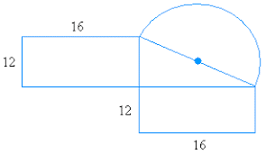
- Prove the hyperbolic identity $2sinh{x}coshx=\sinh{2x}$. (4 marks)
- Evaluate the product of the matrices below. (3 marks)
$\left(\begin{matrix}5 & -3 & 0 \\ 2 & 6 & 7 \\ 3 & 0 & 1\end{matrix}\right)$ × $\left(\begin{matrix}1 & -4 & 0 \\ 0 & 1 & 7 \\ 4 & 2 & 0\end{matrix}\right)$
- Find the equations of the tangent to the curve y = x³ + 3x² + 3x − 7x – 8 at the point Q (2, 1). (4 marks)
- Solve the equation 16^{2x + 1} = 8^{4x – 1}. (3 marks)
- Given that $\sin{x}$ = $\frac{8}{10}$. Evaluate
- $\tan{x}$ (2 marks)
- $\cos{x}$ (2 marks)
SECTION B (60 MARKS)
Answer any three questions in this section.

- Convert the Cartesian equation $x^{2}+y^{2}=36$ into Polar form. (3 marks)
- A cooling tower is in the form of a frustum of a cone. The base has a diameter of 32.0 m, the top has a diameter of 14.0 m and the vertical height is 24.0 m as shown in Figure 1. Calculate the curved surface area of the tower and the. (4 marks)
Figure 1
- Find the value of$x$ in the equation: $3\sinh{x}-2\cosh{x}-2=0$. (6 marks)
- Solve the following system of equations. (7 marks)
$$p+2q+3r+7.8=0$$
$$2p+5 q-r-1.4=0$$
$$5p-q+7r-3.5=0$$

- Using the appropriate half-angle formula, find the exact value of cos(π/6).
(3 marks)
- Using Osborne's rule, derive the formula for $\cosh{2x}$ from the trigonometric identity below.
Cos 2x = 1−2sin2x (3 marks)
- The sum of the first three terms of an arithmetic progression is 3 and the difference between the seventh term and the fourth term is $-6$. Determine
- The first term and the common difference. (4 marks)
- The sum of the first twenty terms. (3 marks)
- Find the equations of the tangent and normal to the curve:
$y = 2x^{3} + 3x^{2} - 2x - 3$ at $P(1,0)$. (7 marks)

- Use the factorisation method to solve the quadratic equation; (4 marks)
$$4x^{2}+8x+3=0$$
- Find the polar coordinates of the point with Cartesian coordinates $\left(-3,-4\right)$.
(4 marks)
- Determine the values of M and N such that: (4 marks)
$$5\cosh{x}-3\sinh{x}=Me^{x}+Ne^{-x}$$
- Figure 2 shows a swimming pool with vertical sides. The swimming pool is 8 m wide.
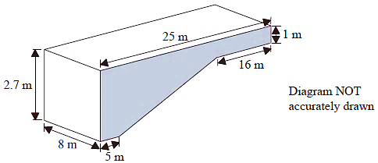
Figure 2

Calculate:
- the area of the shaded cross-section; (4 marks)
- the volume of water in the pool. (4 marks)

- An observer O whose eye is at level with an ocean surface observes that the top of a mast T planted vertically to the bottom of the ocean is 10 meters from his eye at an angle of elevation of 20⁰ and the bottom of the mast B in the ocean to be 8 meters at an angle of depression of 40⁰as shown in Figure 3.
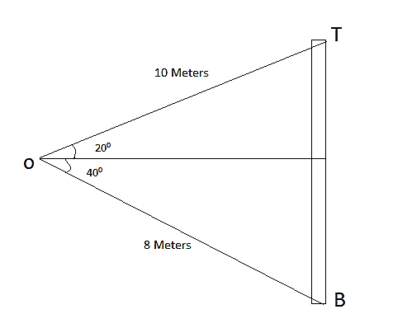
Figure 3
- Find the height of the mast. (3 Marks)
- Find the height of the mast from the surface of the ocean and the depth of the mast from the surface of the ocean. (4 Marks)
- Solve the equation: $\log\left(x-1\right)+\log\left(x+1\right)=2log⁡(x-2)$. (4 marks)
- In a geometric progression, the 5th term is 9 times the 3rd term, and the sum of the 6th and 7th terms is 1944. Determine:
- the common ratio; (3 Marks)
- the first term; (3 Marks)
- the sum of the 4th to 10th terms inclusive. (3 Marks)

