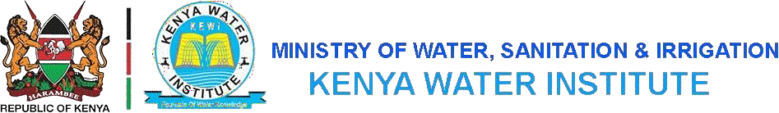

COURSE: DIPLOMA IN WATER ENGINERING TECHNOLOGY
LEVEL:Y1S1
SUBJECT: COMMUNICATION SKILLS

SECTION A (40 MARKS)
1.
- Distinguish between formal and informal communication. (2mks)
- State FOUR benefits of effective communication in an organization. (4mks)
- Highlight FIVE reasons for using telephone communication as a form of communication in an organization. (5mks)
2.
- Explain the term “encoding” as used in communication. (2mks)
- State TWO advantages of using visual communication. (2mks)
- With the aid of a diagram describe the communications process (7mks)
3.
- State TWO purpose of communications (2mks)
- Outline FOUR causes of poor communication between people or organizations (4mks)
- State FOUR advantages of using written communications (5mks)
4.
- State FOUR positive impacts of Grapevine as a form of communication in an organization (4mks)
- Identify any THREE functions of a chairperson in a meeting (3mks)

SECTION B (60 MARKS)
5.
- Outline two purposes of Vertical Communication. (2 marks)
- Highlight two problems associated with vertical Communication channels in an organization. (4 marks)
- List four benefits of office etiquette. (4 marks)
- Explain five factors to consider when choosing a means of communication.
(10 marks)

6.
An interview is a communication transaction in which an interviewer engages in questioning and discussion with an interviewee to gather information.
(a) Highlight the roles of the interviewer in an interview. (5 marks)
(b) List five types of meetings. (5 marks)
(c) Discuss how an interviewee prepares for an employment interview. (10 marks)

7.
- List five characteristics of a good speech. (5 marks)
- Explain five reasons why an organization would choose social media to communicate. (5 marks)
- Communication will be effective if it flows speedily and smoothly in an uninterrupted flow. Discuss five barriers to effective communication. (10 marks)
8.
- State four advantages of using visual aids to communicate. (4marks)
- List four types of meetings that may be held in an organization. (4marks)
- State four causes of poor communication between people or organizations
(4marks)
- State four characteristics of a good listener. (4marks)
- Explain the meaning of the following terms in communication; decoding and feedback. (4marks}

