

AUGUST, 2024 EXAMINATION SERIES
COURSE: CWE
LEVEL: Y2 S1
SUBJECT: MECHANICAL PLANT

SECTION A (20 MARKS)
ATTEMPT ALL QUESTIONS IN THIS SECTION

1. | Which of the following is NOT correct regarding pumps. | - MARK
- Pumps may be classified depending on application
- Pumps may be classified depending on color
- Pumps may be classified depending on material of construction
- Pumps may be classified depending on Installation
2. | State the effect for a pump installation on a concrete foundation which is not substantial enough  - Excessive speed  - Excessive vibration  - Excessive heat on the founding  - Reduced speed of the pump | 1 MARK
3. | Identify a tool below suitable for pump alignment  - Barometer  - Speedometer  - Steel rule  - Hammer | 1 MARK
4. | The term hydraulics comes from Greek words hydro meaning  - Water  - Oil  - Fluid  - Air | 1 MARK
5. | . Pump speed is measured with an instrument known us  - Ammeter  - voltmeter  - speedometer  - Tachometer | 1 MARK
6. | Flow rate has a corresponding equation of  - Q=t/V  - Q=V/t  - Q=VR  - Q = V t | 1 MARK
7. | Flow rate is typically measured in units?  - M³/H  - H/M³  - M/H  - H/M | 1 MARK
8. | Which of the following is a positive displacement pump?  - Reciprocating pump  - Propeller pump  - Centrifugal pump  d)Jet pump | 1 MARK
9. | In a centrifugal pump, the flow is …………………….when the velocity is increase  - Reduced  - Increased  - Greater  - Same | 1 MARK
10. | In a Hydroelectric power plant, the electric power is obtained from  - Chemical energy  - Nuclear energy  - Potential  - Energy of water | 1 MARK
11. | Identify the equipment below  - Distribution panel  - Distribution switch  - Control panel  - Control board  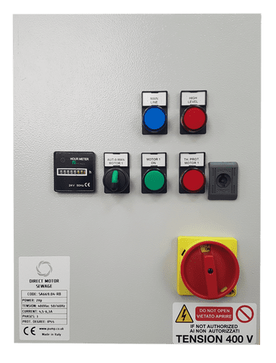 | 1 MARK
12. | The motor used in water supply is commonly  - AC motors  - DC motors  - Dc series  - Reluctance motor | 1 MARK
13. | What is the fundamental principle of operation for a centrifugal pump?  - It uses centrifugal force to increase fluid velocity and create pressure.  - It employs gears and rotors to create pressure  - It uses reciprocating to move fluid  - It relies on the centrifugal force to increase fluid velocity and pressure | 1 MARK
14. | . The rotating part of a DC motor is known as:  - Pole  - Stator  - Rotor  - None of these | 1 MARK
15. | Identify the equipment below  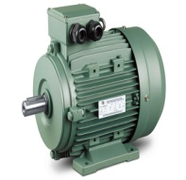  - AC GENERATOR  - DIESEL ENGINE  - AC MOTOR  - DC GENERATOR | 1 MARK
16. | Which of the following pump is based on the type of power?  a) Low lift pump  b) High lift pump  c) Air lift pump  d) Steam engine pump | 1 MARK
17. | 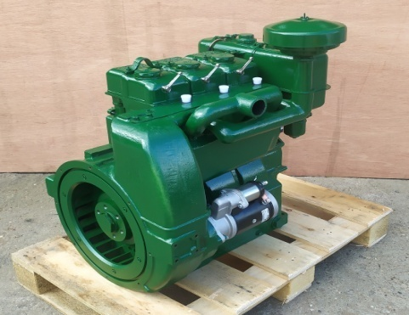  Identify the equipment above  - Bear shaft motor  - Bear shaft generator  - Bear shaft engine  - Bear shaft pump | 1 MARK
18. | What is an air compressor used for ?  - supplying clean high-pressure water to fill water tanks  - supplying clean high-pressure air to fill gas cylinders  - supplying clean high-pressure water to fill gas cylinders  - None of the above | 1 MARK
19. | What is cavitation ?  - The body of the pump, which encloses and protects the impeller and other internal pump components.  - The collapse of gas bubbles in a pump due to the sudden pressure increase.  - A force generated by a rotating body that extends outward from its center.  - The force exerted on the walls of a tank, pipe, etc. by a liquid. Normally measured in pounds per square inch (psi | 1 MARK
20. | Define pump Head  - Process in which small bubbles are formed and implode violently; occurs when NPSHa < NPSHr.  - The force exerted on the walls of a tank, pipe, etc. by a liquid.  - Maximum vertical distance (in metres) from pump to point of discharge with no flow.  - A measure of pressure, expressed in meters for centrifugal pumps. | 1 MARK

SECTION B (40 MARKS)
ATTEMPT ALL QUESTIONS
- Explain why the headroom clearance of all pump houses should be a minimum of 2.75m 4 marks
- What process in plants was the inspiration for a solar powered water pump design? 5 marks
- How does cavitation affect pump life 3 marks
- What are the factors considered for centrifugal pump design? 3 marks
- A centrifugal pump having hydraulic power of 22KWH and discharge and suction head of 55m and 12m respectively. Assuming the density of water is 1000kg/cubic, calculate the pump flow. 5 marks

What is specific speed, and what is its effect on the pump curve? 3 marks
- Identify factors considered in pump classification 3 marks
- Discuss how you identify a centrifugal pump 3 marks
- Identify problems associated with centrifugal pumps and how to curb them
3 marks
- A centrifugal pump rated 75 cubic and total head 35m is supplying water to fill a tank in 2 hours. Calculate the total power consumption. Consider pump and motor efficiency of 55% and 85% respectively. 5 marks

SECTION C 40 MARKS
ANSWER ANY TWO QUESTIONS
- a) With the aid of a drawing show parts of a hand pump 10 marks
- Explain the following terms as used in pumping 6 marks
- Head
- Specific Speed
- Capacity
- Discuss reciprocating pumps under the following heading 4 marks
- Discharge
- Speed
- a) Discuss five classifications of mobile cranes 10 marks
- Mutua from KEWI was called to advice a farmer on his pump that was not working, he discovered that no body serviced it by the time was installed. Discuss the maintenance of the pump, Mutua operated for the pump to start working 10 marks
- a) By a show of diagram, draw an impeller and discuss how it operates 10 marks
b) A centrifugal pump rated 75 cubic and total head 35m is supplying water to fill a tank in 2 hours. Calculate the total power consumption. Consider pump and motor efficiency of 55% and 85% respectively. 10 marks

