

AUGUST, 2024 EXAMINATION SERIES

COURSE: CWET
LEVEL: Y1S2
SUBJECT: TECHNICAL DRAWING

SECTION A (20 MARKS)
ATTEMPT ALL QUESTIONS IN THIS SECTION

- Initial work and construction lines are drawn using __ pencil (1 mark)
a) 3H
b) 4H
c) H
d) 2H
- Centre lines, section lines are drawn using __ pencil (1 mark)
a) H
b) 2H
c) 3H or 4H
d) HB
- The line given below is used for____________ (1 mark)
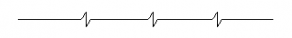
a) Long-break line
b) Cutting planes
c) Centroidal lines
d) Out lines of adjacent parts

- The line given below is used for_________________ (1 mark)
a) Hidden outlines
b) Cutting planes
c) Hidden edges
d) Dimension lines
- Dashed thick (wide) line is represented by (1 mark)
a) ____________
b)
c)
d)

- Drawing pencils are graded according to increase in relative __________ (1 mark)
a) diameter
b) sharpness
c) length
d) hardness
1. | Dimension lines | I. Continuous thick lines
2. | Extension or Projection lines | ii. Continuous thin lines
3. | Margin lines | iii. Continuous thick lines
4. | Outlines | iv. Continuous thin lines
- Match the following (1 mark)

- 1, i; 2, ii; 3, iii; 4, iv
- 1, ii; 2, iii; 3, iv; 4, i
- 1, ii; 2, iv; 3, iii; 4, i
- 1, iv; 2, iii; 3, ii; 4, i

- Short-break lines are drawn freehand while long-break lines are ruled lines
(1 mark)
a) True
b) False
- In engineering drawing, which type of line indicates a change of plane? (1 mark)
a) Continuous thin wavy
b) Long chain thin
c) Continuous thick
d) Medium thick short dashes
- Which of the following lines are used to show that the object is cut and then viewed? (1 mark)
a) Hidden lines
b) Leader lines
c) Centre lines
d) Hatching Lines

- What do hidden lines in orthographic projections denote? (1 mark)
a) Holes or slots
b) Change of Plane
c) Position of cut
d) Centre of a circle or cylinder
- From the below figure, what is the name of the line X? (1 mark)
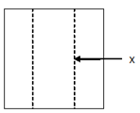
a) Outline
b) Section line
c) Hidden line
d) Hatching
- The axis of the cylinder or sphere is denoted by which of the following line?
(1 mark)
a) Section line
b) Centre line
c) Hidden line
d) Leader line
- What is the standard length and width of the arrowhead of dimension lines?
(1 mark)
a) 2mm and 2mm
b) 3mm and 1mm
c) 4mm and 2mm
d) 3mm and 2mm
- While dimensioning a circle, the leader line and the dimension line are drawn at which angle with respect to each other? (1 mark)
a) 45˚
b) 30˚
c) 0˚ or 180˚
d) 90˚
- Which are the two systems of placing dimensions? (1 mark)
i. Aligned system, ii. Break system, iii. Unidirectional system, iv. Directional system
a) i, ii
b) i, iii
c) ii, iv
d) i, iv
- What is the height if the dimension figures written on the dimension line?(1 mark)
a) 7mm to 9mm
b) 2mm to 3mm
c) 6mm to 8mm
d) 3mm to 5mm
- If a plane is parallel to the plane of projection, it appears (1 mark)
- As a line or edge
- Foreshortened
- True size
- As an oblique surface
- Which of the following is NOT a rule for sectioning (1 mark)
- A section lined area is always completely bounded by a visible outline
- The section lines in all areas should be parallel. Section lines shown in opposite directions indicate a different part
- All the visible edges behind the cutting plane should be shown
- All of the above are rules
- Which of the following type of view shows the object all the ways through as if it were transparent (1 mark)
- Planar
- Orthographic
- Auxiliary
- Horizontal

SECTION B

- What is 2D drawing (2 marks)
- What is 3D drawing (2 marks)
- How is 3D drawing different from 2D drawing (2 marks)
- Outline the procedure for drawing the borderline (4 marks)
- Outline the procedure for drawing the title block (5 marks)
- What is sketching in engineering drawing (3 marks)
- What is projection in engineering drawing (3 marks)
- Highlight the difference between aligned and unidirectional dimensioning styles (4 marks)
- Describe working drawing as used in the technical drawing (3 marks)
- What is the ratio of length to width of the dimensioning arrow head (4 marks)
- Describe the three principal planes of projection in technical drawing (6 marks)
- Describe scale as applicable in engineering drawing (2 marks)

SECTION C (40 MARKS)
ANSWER ANY TWO QUESTIONS IN THIS SECTION
- Using drawing instruments of your choice, produce the sketches of the front, plan, and side views of the image shown below (20 Marks)

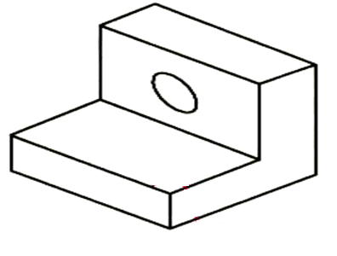
- Draw orthographic projection of the given object by first angle projection method
(20 marks)
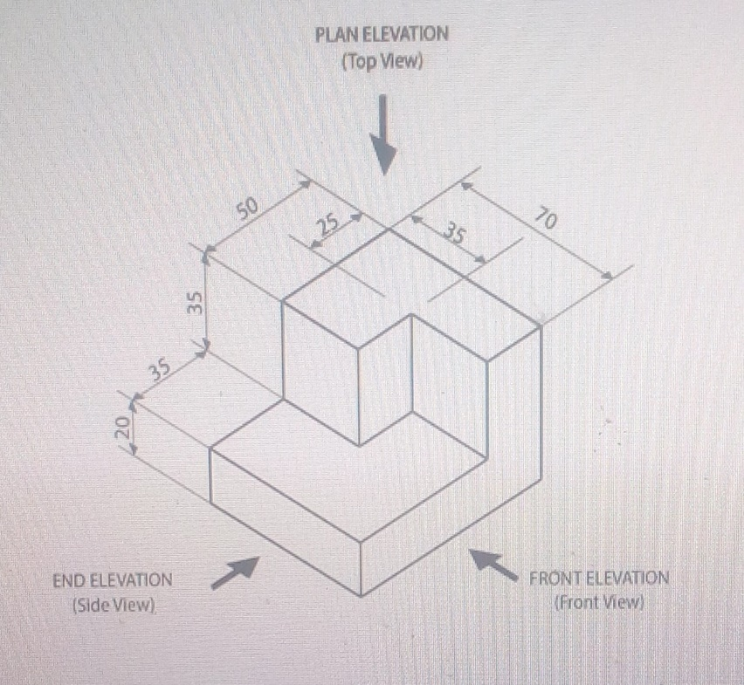

- Using universal method, construct a regular Pentagon (20 marks)

