

AUGUST,2024 EXAMINATION SERIES
COURSE: CERTIFICATE IN WATER ENGINERING
LEVEL: Y1S1
SUBJECT: APPLIED PHYSICS

SECTION A (20 MARK)
Answer all questions in this section each question carries 1 mark
- Which of the following is a renewable source of energy?
- coal
- natural gas
- tidal
- geothermal
- Identify the physical unit that does not match its SI unit.
- Force –Newton
- Energy-Joule
- Frequency-Hertz
- Work-Kilograms
- Which of the following best defines retardation?
- The velocity of a body at a specific moment.
- The acceleration of a body when velocity changes at a constant rate.
- The acceleration of a body when its velocity decreases over time.
- The acceleration of a body when its velocity increases over time.
- Which of the following best defines momentum?
- The ability to do work.
- The branch of physics that deals with motion.
- The product of a body's mass and its velocity.
- The tendency of a body to remain at rest.
- Energy exists in many forms. Which of the following is not a form of energy?
- Gravitational
- Chemical
- Mechanical
- Longitudinal
- Which of the following is not a source of energy?
  - Wind
  - Sun
  - Hydropower
  - Heat

- Which of the following is not a change of state of matter?
  - Cooling
  - Condensation
  - Sublimation
  - Freezing
- Which of the following best describes temperature?
- Degree of hotness or coldness of a body
- Transfer of thermal energy from one body to another
- Expansion or contraction of a body
- Movement of particles
- Heat is transferred in many ways. Which of the following is not a mode of heat transfer?
  - Conduction
  - Radiation
  - Radiators
  - Convection
- Which of the following equations represents pressure in fluids?
  - $ma$
  - $mgh$
  - $\frac{1}{2}mv^{2}$
  - $F/A$
- Which of the following is not a property of light?
  - Travels faster than sound
  - Visible
  - Travels in a straight line
  - Can be touched
- Which of the following states best describes tightly packed particles?
  - Solids
  - Liquids
  - Gases
  - All of the above

- Which of the following best describes the refraction of light?
  - Bending of light
  - Bouncing of light
  - Light resistivity
  - None of the above
- Select the correct definition for a transverse wave:
  - Oscillations are perpendicular to the direction in which the waves transfer energy
  - Oscillations are at 45 degrees to the direction in which the waves transfer energy
  - Oscillations are in the same direction in which the waves transfer energy
  - Oscillations are parallel to the direction in which the waves transfer energy
- Given a wave with a period of 4 seconds, what is the frequency of the wave?
  - 4 Hz
  - 25 Hz
  - 0.25 Hz
  - 40 Hz
- A reflected sound is known as:
  - A repeat
  - An echo
  - A return
  - A reverberation
- Pressure is measured by an instrument called:
  - Accelerometers
  - Barometers
  - Callipers
  - Screw gauge
- In which field is the equation of continuity applied?
  - Energy dynamics
  - Fluid dynamics
  - Heat dynamics
  - Mechanics

- Identify the reading in the vernier callipers below
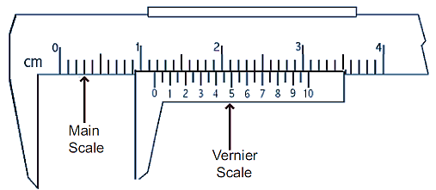

- 1.51cm
- 1.32cm
- 1.12cm
- 1.165cm
- Which of the below best defines density?
- $\frac{Mass}{Volume}$
- $\frac{Force}{Area}$
- $\frac{Volume}{Mass}$
- $\frac{Area}{Force}$

SECTION B (40 MARKS)
Answer all questions in this section

  - Define the term moment of a force. (1 mark)
  - List THREE effects of a force. (3 marks)
  - State THREE types of force. (3 marks)
  - Using the Newton’s second equation of motion, show that $F=ma$. (3 marks)

  - List THREE basic fundamental units of measurement. (3 mark)
  - Explain why a fish pond appears shallower than its actual depth. (2 marks)
  - Give a reason why heat and light from the sun reach the earth's surface. (2marks)
  - State THREE physical states of matter. (3 marks)
- A pupil measured the volume of a potato using the items of laboratory equipment, labelled A and B as shown in the diagram.
  - Name the items labelled A and B. (2 marks)
  - What was the volume of the stone in cm³? (1 mark)
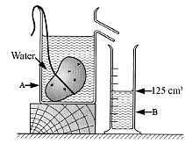

  - A body covers a distance of 10m in 4 seconds. It rests for 10 seconds and finally covers a distance of 90m in 60 seconds. Calculate the average speed.
  - A body moving with a uniform acceleration of 10 m/s² covers a distance of 320 m. If its initial velocity was 60 m/s. Calculate its final velocity. (4 marks)
  - A body is uniformly accelerated from rest to a final velocity of 100m/s in 10
seconds. Calculate the distance covered. (3 marks)

  - A truck weighs 1.0×10⁵ N and is free to move. What force will give it an acceleration of 1.5 m/s²? (take g=10N/kg). (3 marks)
  - A car of mass 1,200 kg travelling at 45 m/s is brought to rest in 9 seconds. Calculate the average retardation of the car and the average force applied by the brakes. (3 marks)
  - Read the following micrometre measurements. (4 marks)
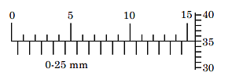
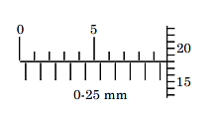

SECTION C (40 MARKS)
Answer ANY TWO questions in this section

  - Define the following physical properties of fluids. (4 marks)
- Density
- Temperature
- Pressure
- Fluid velocity
  - Outline the Bernoulli’s principle. (2 marks)
  - Read the following Vanier calliper measurements. (4 marks)
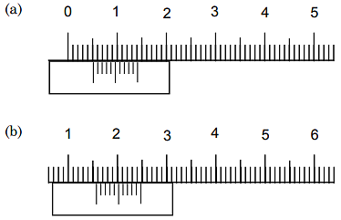

  - Discuss the three modes of heat transfer. (6 marks)
  - A ball is projected vertically upwards with an initial velocity of 3 m.s⁻¹. Ignoring air friction, calculate:
- the maximum height reached by the ball; (2 marks)
- the time taken for the ball to return to the ground. (2 marks)

  - The figure below is a wooden block of volume 90 cm floating with 1/3 of its body submerged in water of density 1gcm-3 (g = 10 Nkg-1)
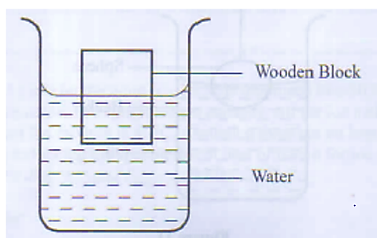

Determine:
- The weight of the block. (5 marks)
- The weight of a metal block that can be placed onto the block so that its top surface is on the same level as the water surface. (5 marks)
  - The figure below shows a solid metal suspended in oil using a thread.
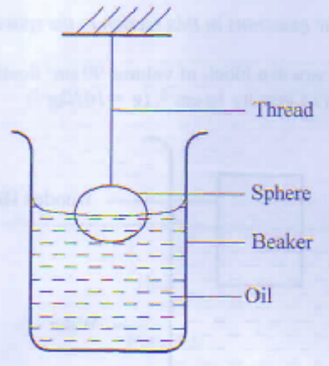
- Other than upthrust, list two other forces acting on the sphere. (4 marks)
- The oil is carefully and gradually drawn from the beaker. State the effect on each of the two forces in (i) above. (6 marks)

  - Define the term "specific latent heat of fusion" (1 mark)
  - Ice with a mass of 5g at a temperature of -10°C is immersed into 10.5g of hot water at 100°C in a container of negligible heat capacity. All the ice melts and the final temperature of the mixture is 40°C. Assuming there are no heat losses to the surrounding and taking the specific latent heat of fusion for ice as L (Cwar = 4200 Jkg-K and C = 2100 Jkg 'K).

Determine the:
- heat lost by the hot water. (4 marks)
- heat gained by ice from -10°C to 0°C. (4 marks)
- heat required to melt the ice in terms of Lf. (4 mark)
- heat gained by the melted ice. (4 marks)
- specific latent heat of fusion of ice. (3 marks)

